**MOBSF**

Documentation Link: **https://mobsf.github.io/docs/#/develop?id=static-analysis**

**Requirements for setting up MobSF locally**.

System Requirements: **8GB+ RAM, 3GHz CPU, 80GB+ Free Disk Space**

Operating System: **Ubuntu 22.04**

**Installation Procedure**

mkdir mobsf

cd mobsf/

**# Install Git**

sudo apt install git -y

**# Install Python 3.10+**

python3 --version

sudo apt update

sudo apt install python3.10 python3.10-venv python3.10-dev -y

**# Install OpenJDK 21+ and configure JAVA_HOME environment variable**

sudo apt update

sudo apt install software-properties-common -y

sudo add-apt-repository ppa:openjdk-r/ppa -y

sudo apt update

sudo apt install openjdk-21-jdk -y

java -version

sudo update-alternatives --config java

java -version

**# Open the .bashrc (or .zshrc) file for editing**.

nano ~/.bashrc

**# Add these lines at the bottom**

export JAVA_HOME=/usr/lib/jvm/java-21-openjdk-amd64

export PATH=$JAVA_HOME/bin:$PATH

**# Save the file and then reload it**

source ~/.bashrc

**# Verify that JAVA_HOME is set correctly, result should see: /usr/lib/jvm/java-21-openjdk-amd64**

echo $JAVA_HOME

**# Install the following dependencies**:

sudo apt install python3-dev python3-venv python3-pip build-essential libffi-dev libssl-dev libxml2-dev libxslt1-dev libjpeg8-dev zlib1g-dev wkhtmltopdf -

**Installation of MOBSF**

**# Clone the MobSF repo (switch to the root user)**

sudo su

git clone https://github.com/MobSF/Mobile-Security-Framework-MobSF.git

cd Mobile-Security-Framework-MobSF

./setup.sh

**# Run a Genymotion Android VM before starting MobSF**.

./run.sh 127.0.0.1:8000

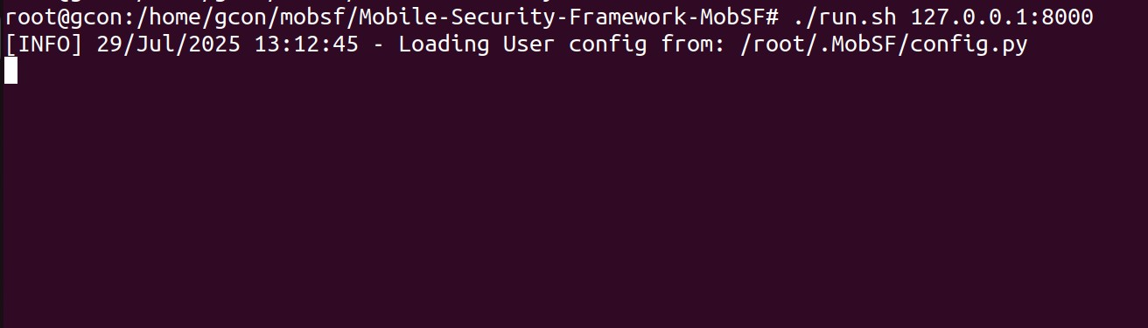

**# MobSF server will listen on 127.0.0.1:8000. In your web browser, navigate to http://127.0.0.1:8000/ to access MobSF web interface. The default credentials are mobsf/mobsf.**

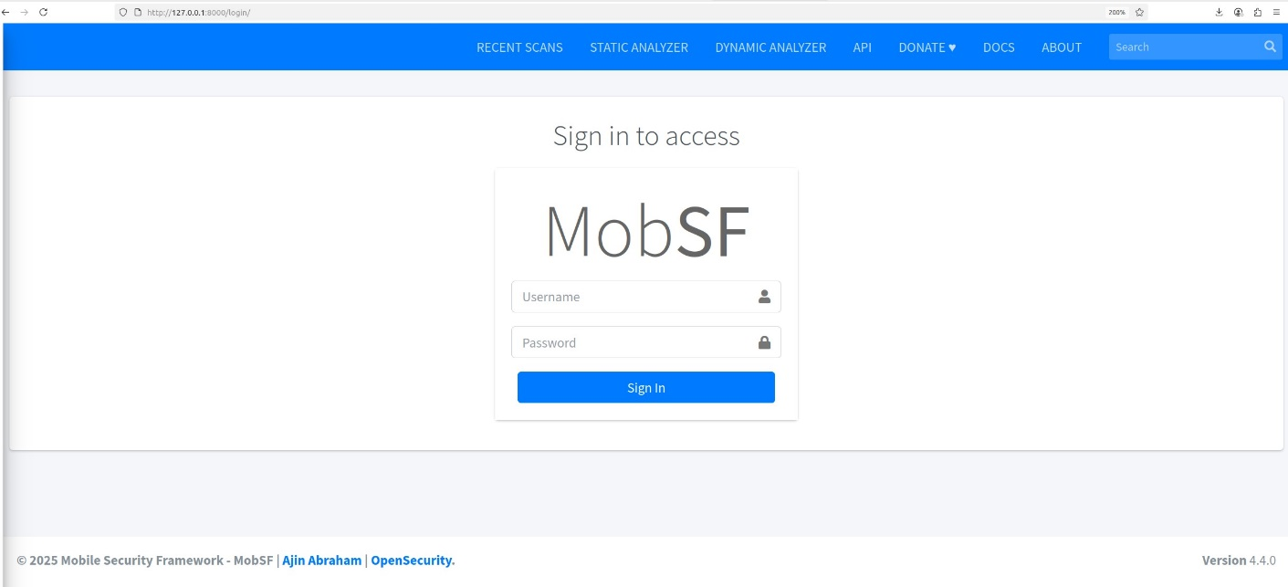

**Installation of Genymotion Android**

**# Genymotion is the preferred dynamic analysis environment that you can setup with the least friction. Run a Genymotion Android VM before starting MobSF.**

https://www.genymotion.com/download/

**# Download genymotion linux installer (https://dl.genymotion.com/releases/genymotion-3.9.0/genymotion-3.9.0-linux_x64.run)**

cd /home/$user$/Downloads

mv genymotion ~/genymotion

~/genymotion/genymotion

ll

chmod +x genymotion-3.9.0-linux_x64.run

./genymotion-3.9.0-linux_x64.run

**# Open Genymotion and create account**

Username :- xxxxxxxxx@xxxx.com

Password :- xxxxxxxxx

**# Create virtual device**

Google Pixel

CPU 4

Memory - 4 GB (Minimum)

Disk size - 32 GB

Android Version - Android 11.0.0

Android API - API 30

Architecture - x86_64

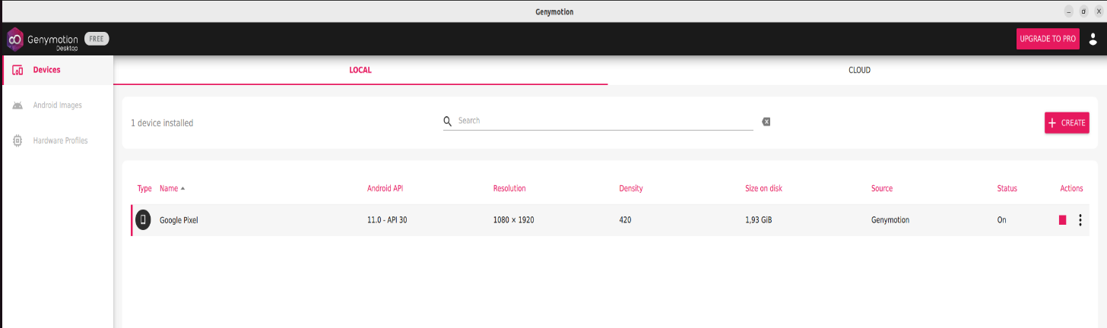

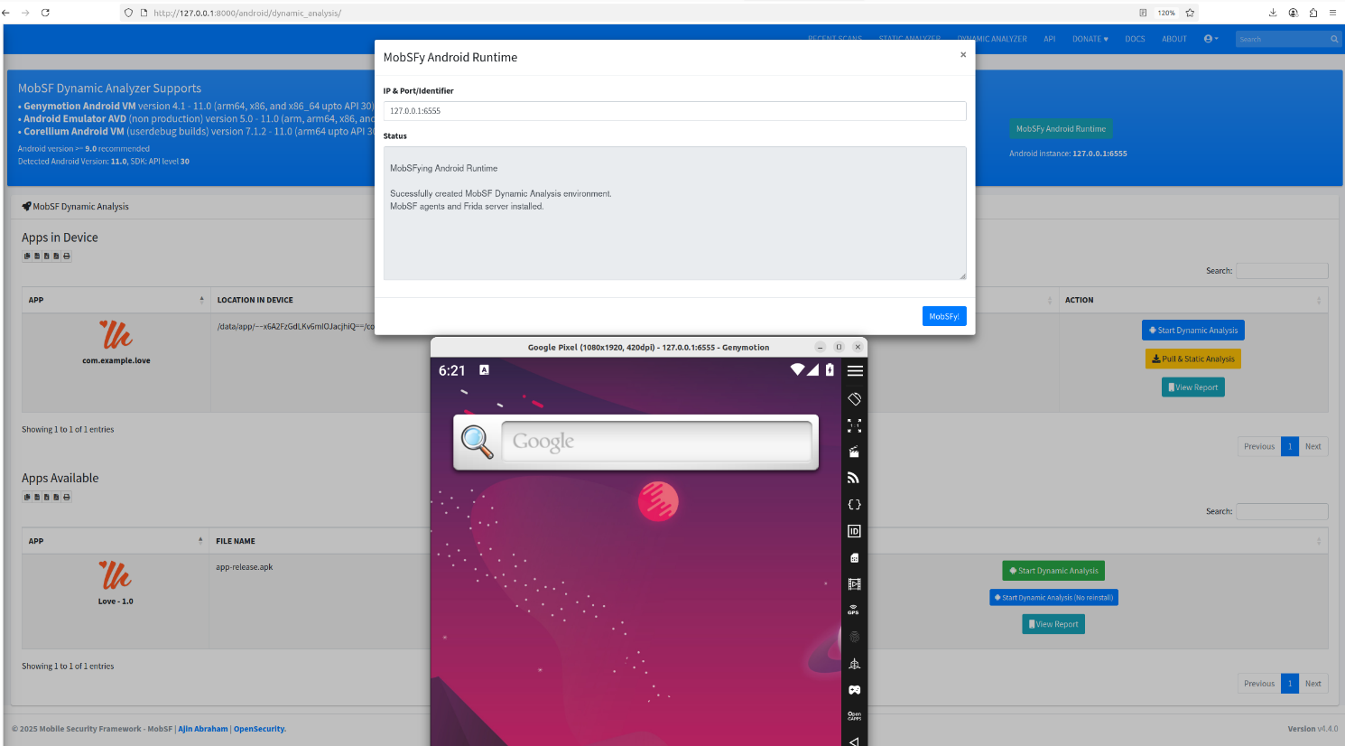  
# After running the Android VM, you can see the device identifier from the title bar

**Note**:-

* ./run.sh 127.0.0.1:8000 # Run this command with Sudo (MobSF needs access to system tools like ADB, file unpacking, and local services that may require elevated privileges).
* adb devices # Ensure MobSF can detect the device/emulator before dynamic analysis.
* Run a Genymotion Android VM before starting MobSF.
* Only Android AVDs upto version 11, API 30 is supported! Newer Android AVDs does not offer a writable **/system** and hence cannot work with MobSF.
* Android 5.0 - 11.0 - These versions uses Frida and works out of the box with zero configuration or setup.

**Dynamic Analyzer**

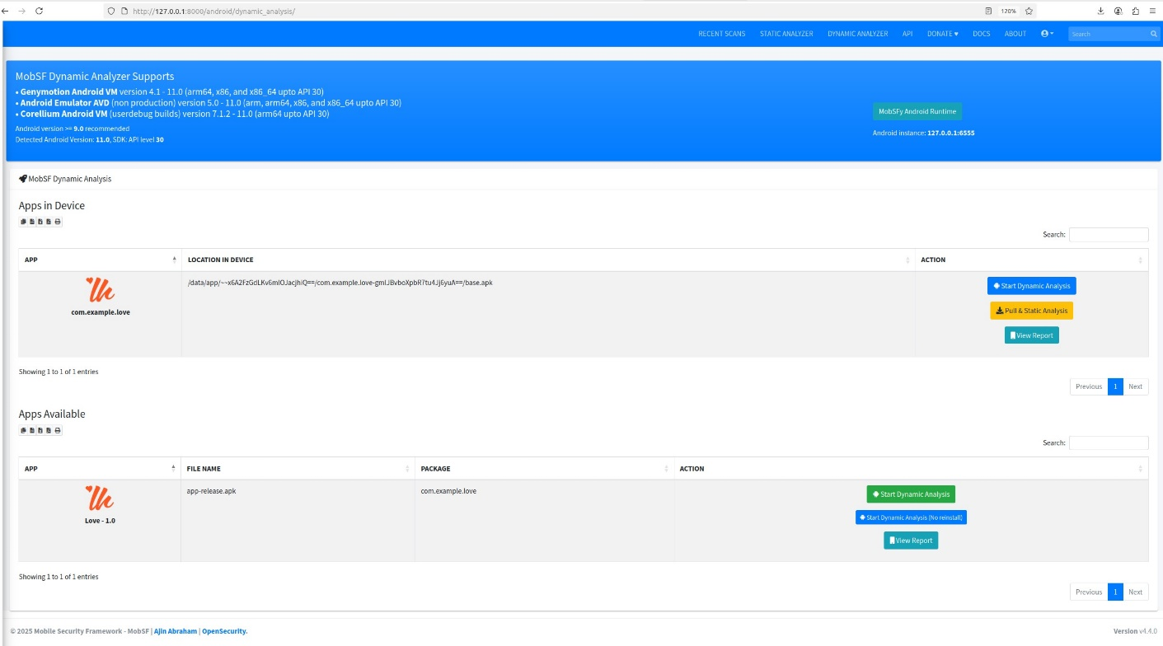

**Ensure MobSF can detect the device/emulator before Dynamic Analysis**



**MobSFy Android Runtime**

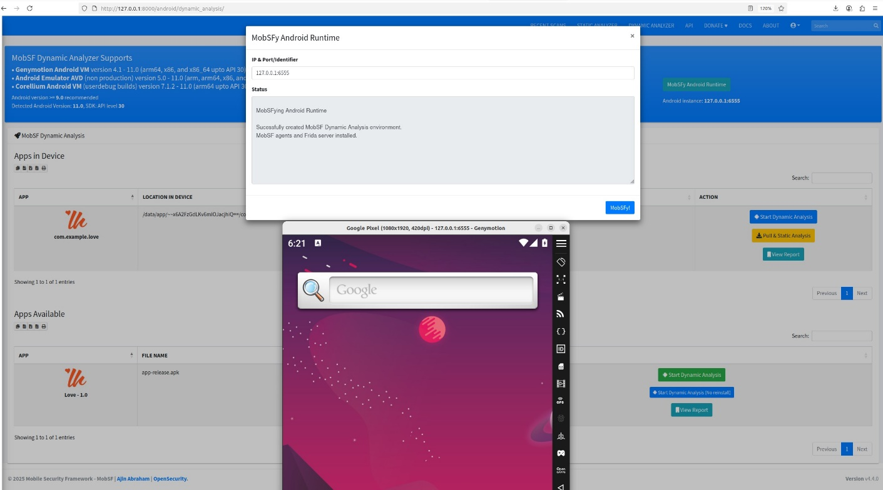

# Click MobSFy Android Runtime button in Android Dynamic Analyzer page to MobSFy the android runtime environment.

**MobSF Console Output**

